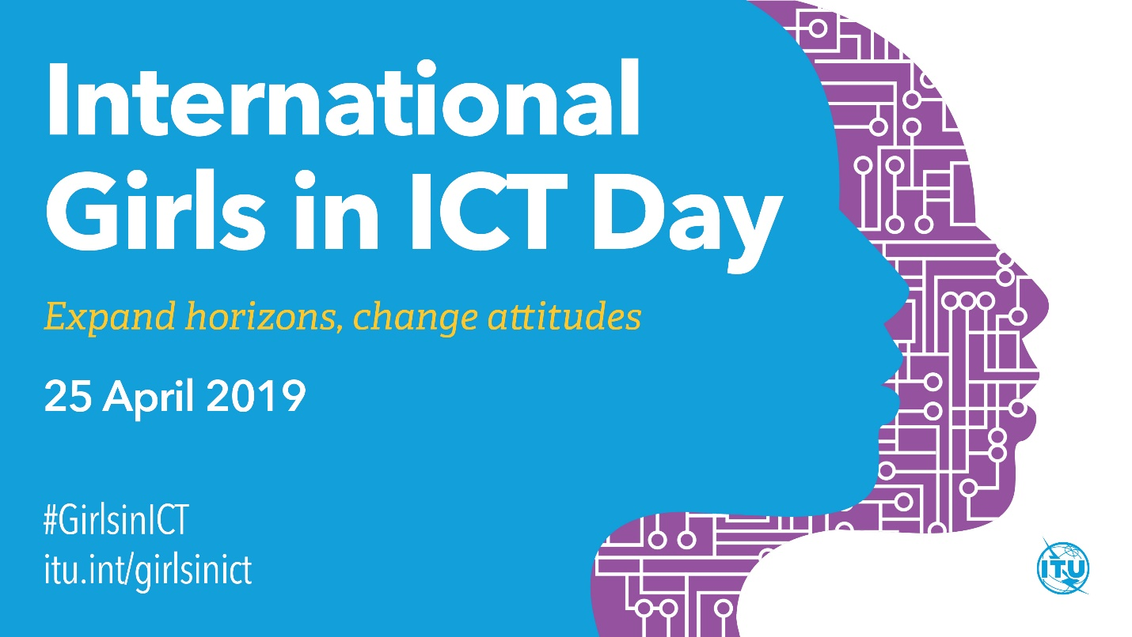

ICT for Women & Women for ICT

*Kabul, Afghanistan*

Contents

**ABOUT INTERNATIONAL GIRLS IN ICT DAY** 3

**ABOUT INTERNATIONAL TELECOMMUNICATION UNION (ITU)** 3

**ABOUT INTERNATIONAL GIRLS IN ICT DAY AFGHANISTAN** 3

**WHY GIRLS IN ICT DAY** 4

**THE ADVANTAGES OF GIRLS IN ICT** 4

**THE EVENT GOALS** 5

**THE EVENT PROGRAM** 5

**INTENDED OUTCOME OF THE EVENT** 6

**HOW YOU CAN GET INVOLVED?** 6

**THE TEAM** 7

# **ABOUT INTERNATIONAL GIRLS IN ICT DAY**

The International Telecommunication Union (ITU), as the leading United Nations agency for telecommunications and ICTs, seeks to encourage gender balance in the ICT sector at all levels of the profession.

International Girls in ICT Day, an initiative backed by all ITU Member States in ITU Plenipotentiary Resolution 70 (Rev. Dubai, 2018), aims to create a global environment that empowers and encourages girls and young women to consider car​eers in the growing field of ICTs, enabling both girls and technology companies to reap the benefits of greater women participation in the ICT sector. International Girls in ICT Day is celebrated every year on the fourth Thursday of April and will next be observed on **25 April 2019​**.

The Girls in ICT day is celebrated worldwide every year on the fourth Thursday of April, which is an opportunity for girls and young women to see and experience technology in a whole new light. Since International Girls in ICT Day was first celebrated in 2011, over 357 000 girls and young women from 171 countries have taken part in more than 11 100 events. This year, the event will be celebrated on 25 April 2019.

ITU’s Girls in ICT believes that after 8 years of awareness raising, it is important to leverage the message of their global campaign and include concrete actions, aiming to contribute to the active participation of women and girls in ICT sector!

Therefore, this year’s campaign will have an additional message: to ‘***Make every day* *Girls in ICT Day****.*’ Therefore, besides organizing and participating in the 2019 global events, all ITU members and partners are encouraged to consider implementing follow-on activities throughout the year to continue helping girls gain the enthusiasm, skills and confidence necessary to become tomorrow’s ICT students and professionals.

# **ABOUT INTERNATIONAL TELECOMMUNICATION UNION (ITU)**

The International Telecommunication Union (ITU; French: Union Internationale des Télécommunications (UIT)), originally the International Telegraph Union (French: Union Télégraphique Internationale), is a specialized agency of the United Nations (UN) that is responsible for issues that concern information and communication technologies. It is the oldest among all the 15 specialised agencies of UN.

# **ABOUT INTERNATIONAL GIRLS IN ICT DAY AFGHANISTAN**

International Girls in ICT Day was first celebrated in 2018 by the Ministry of Communications and Information Technology in Afghanistan.

This year, the Association of Afghan Girls in ICT is planning to celebrate this day on April 2019 with at least 150 participants from various sectors such as academia, government, civil society and the private sector. The event will be organized in close

partnership and support with a number of international and national organizations operating for similar purposes in Afghanistan.

# **WHY GIRLS IN ICT DAY**

**Supporting the education of women and girls in the ICT sector is also in line with United Nations Sustainable Development Goals (SDGs);** in particular SDG 5, aimed at achieving gender equality and empowering all women and girls through, among others, Information and Communication Technologies. Not only are jobs in the ICT sector lifting women out of poverty, a more gender-balanced sector offers fulfilling mid and high-level careers, and enables highly talented women to springboard to the top of the career ladder. This is good for everyone.  As UN Secretary General Ban Ki-moon has said, "Equality for women and girls is not only a basic human right it is a social and economic imperative. Where women are educated and empowered, economies are more productive and strong.  Where women are fully represented, societies are more peaceful and stable."

Information and Communication Technologies (ICTs) drive growth and innovation worldwide, infiltrating all aspects of our lives. These ongoing advances in ICTs effectively make digital literacy a prerequisite for employment and entrepreneurship opportunities and are leading to a projected shortage of at least 2 million ICT employees worldwide by 2020. Studies show that not enough young people are choosing careers in ICT - especially not enough young women. Expanding the global and local technology talent pool to include more women with ICT skills can help fill this gap. This means investing in girls and young women today for future tech job.

# **THE ADVANTAGES OF GIRLS IN ICT**

1. **Supporting the global Girls in ICT movement empowers girls and young women, giving them the confidence to pursue ICT studies and careers.** Girls and young women have the potential not only to become ICT users, but also to become ICT creators. And the good news is that jobs as ICT creators often offer higher salaries and lower gender-based pay gaps than in other fields.
2. **One of the best reasons is that there are job opportunities in the ICT sector!** The sector is marked by a pressing need for a wide range of ICT talents. This means that highly qualified women in technical fields have significant opportunities available to them;
3. **ICT companies are looking to attract and promote women because achieving greater workforce diversity is good for business.**The lack of young women attracted to ICT studies is reflected in ICT companies and government agencies around the world.  The ICT sector is currently male dominated, especially at senior levels. Where women are present, it is often in low-level, low-skilled jobs. Fortunately, many companies are looking to increase the numbers of women in the sector. A broad range of organizations and companies have concluded that increasing women at the top positively impacts financial performance, while those that ignore diversity issues risk ongoing labor shortages;
4. **Girls in ICT Day events make girls and young women aware of the vast possibilities ICTs offer, quelling misconceptions about the sector and inviting them to envision their future as ICT creators;**
5. **Encouraging women and girls to pursue ICT careers also fosters a more dynamic technology sector, posing extensive benefits for companies**. A more gender-balanced workforce reflects the customer base more accurately, enhances productivity and innovation and leads to better financial results.

# **THE EVENT GOALS**

*ICT for Women and Women for ICT*

This year’s program focuses on discussing and showcasing four main aspects:

1. ICT for Women: How developing technology can support women’s development and livelihood activities;
2. Women for ICT: How ICT sector can benefit from women active participation through promoting gender equality in education, careers and leadership;
3. Encouraging and supporting the role of women in ICT at national and grassroots level through their engagement, educating, skills building and then promotion;
4. Appreciating Afghan women roles models in ICT;
5. Launch of a number of programs as a concrete action for women inclusion and support in ICT field.

# **THE EVENT PROGRAM**

This year's event will be the first of its kind in Afghanistan and the program’s four main activities ware as below:

1. **The Event Day on April 25th:**

The event day is the main meeting of ICT industry, starting from academia to business, from private sector to civil society. The event day will focus on the exhibition and presentation of ICT, in particular women's lives and benefits of women in the ICT industry, as well as current challenges and ways of moving forward. The event day will host a number of influential speakers to give a chance to participants to hear their inspirational story and achievements as well as how they are contributing to include more women in ICT industry.

1. **The Expo**

Expo is the ICT exhibition associated with the event day for girls and women showcase their ICT companies, services and products and any developed social applications. If you are an owner or operator of a women ICT company, we invite you to apply as an exhibitor.

1. **Appreciation of Women Role Models in ICT**

The event will also be hosting an appreciation ceremony on the event day. We plan to appreciate the great work of Afghan women and girls in the ICT industry. If you are the one or know someone you think is eligible, please apply to or share this opportunity with them.

1. **Career Fair**

The event also provides an opportunity for potential employers and companies and women students with ICT background to meet one another, establish professional relationships, and discuss potential job and/or internship opportunities.

1. **Pre-event Digital Literacy Course**

The event organizers plan to provide one week long digital literacy course women students of girl’s high school in Kabul. For this, we plan to train at least 200 girls high school students as well as 100 students of The Blind School of Kabul.

1. **Official Launch of a number of long-term programs**

The organizer of the event also plans to officially launch 1 - 2 programs to engage, educate, support and empower women and girls in the ICT study, career and business development.

# **INTENDED OUTCOME OF THE EVENT**

The desired outcome for the Girls in ICT Day is to open a space for inspiration, dialogue and future collaboration between different actors who will participate in the event from academia, government, private sector, civil society and media and discuss issues of Girls in ICT such as the challenges, the benefits, the acquired actions steps in order to showcase the impacts and improvement as a result of this program as well as discussing the social, economic and educational benefits to the industry and Afghanistan.

The Girls in ICT Day will also provide a platform for women and girls in ICT field to connect, network and share knowledge and get inspired by women role models in the field as well as will encourage them to pursue study and careers in the field. The event will also help women and girls in ICT to know about the ICT companies and get awareness about the career destination they can make through pursuing ICT education.

# **HOW YOU CAN GET INVOLVED?**

Below are some of the ways, you can support the event and program:

1. **Apply as a Guest Speaker**

If you are a man or woman and having ICT expertise and high profile and have something to share an inspirational story or experience with the participants, please apply as speaker to the event day.

1. **Apply as a Participant**

If you are a woman with ICT study or career background who is interested in learning, sharing knowledge and experience and engaging with your peers from ICT industry? Apply for the day of the event.

1. **Apply as an Exhibitor**

If you have an ICT company, service and product and interested to showcase in the event day or plan to attract caliber women job seekers, please register online now as exhibitor.

1. **Become a Sponsor**

The event day hosts potential speakers, high-profile guests from ICT industry, academia, civil society, government and representatives from media which provides a golden visibility chance for ICT companies to showcase their firms, products and services. If interested, please register as a sponsor.

1. **Apply as a Volunteer**

The event organizer is looking for passionate volunteer women who are interested in practical learning and gaining work experience for the period of 2 months. If you are the one, please apply as volunteer.

1. **Apply as volunteer Trainer**

The event seeks a number of volunteer ICT trainers who can help us with the two-week digital literacy courses at the girls' high schools in Kabul. If you are interested in supporting our programs and contributing to the big aim, please apply as an ICT trainer.

# **THE TEAM**

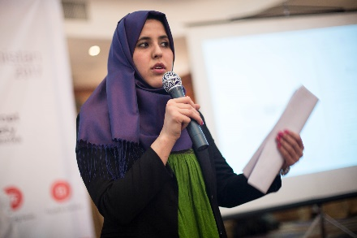***Shabana Mansoory***

Ms. Shabana is a dynamic young woman leader in Tech in Afghanistan. She has undergraduate degree in Computer Science from Kabul University. She had started her career from being a Database developer to co-founding TechWomen Afghanistan. She was an active member to the series of biggest innovation lab program in the country, “iLabs Afghanistan” during 2012-2018. She was also appointed as Chief Information Officer (CIO) for e-Governance project of Ministry of Communications and Information Technology of Afghanistan. Ms. Shabana co-organized the first of its type workshop by name of TechWomen in central and south Asia in the Internet Governance forum in 2016 in Mexico and then in 2017 in Switzerland. During 2018, she presented Afghanistan in the Middle East & Adjoining Countries School on Internet Governance (MEAC SIG) in Egypt and then in ITU Regional Conference on ICT for Women in the Arab Region in Lebanon. Ms. Shabana is associated with a number of initiatives in Afghanistan, such as the first Youth to Business Forum in 2014, TechWomen Afghanistan in 2015, and Internet Society (ISOC) Afghanistan Chapter in 2016. She is also the current board member of Internet Society (ISOC) Afghanistan, where her main focus and contribution is on projects and policies which supports inclusion of women towards use of internet for benefits.

Over all, Ms. Shabana’s work is mainly focusing on the social and cultural change of women through promoting and use of internet and technology as well as nurturing women entrepreneurs and startups through skills development and business coaching and nurturing technological Entrepreneurship and she is a considerable activist for women and girls’ engagement and empowerment in Tech Education, Tech Entrepreneurship and Innovation. She received letter of appreciation from the Afghan Minister of Communications and Information Technology for her efforts in the field of ICT development for women in 2018. She is fluent in Dari, Pashto, English, Urdu and Arabic.

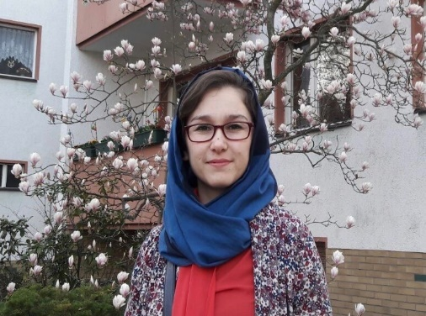

***Tayebe Abidi***

Ms. Tayeba has earned a BA in computer science from Kabul University and her master degree in Computer Science from the Technical University of Berlin through DAAD Scholarship. Her last year study focused on “Emerging Trends and Technologies in Open Education and the Impact on Afghanistan”. She is lecturer in IT department of Computer Science faculty at Kabul University and as well she is the Head of Education department in IT Competence and Research Center (ITCC) in Ministry of Higher Education (MoHE) of Afghanistan. During her master’s study, she also wrote a research report on use of ICT for advancing educational opportunities for Afghan women. She also received fellowship of Afghan Junior Faculty Development Program from Department of State in Indiana University, Indiana, U.S. in 2016 and DAAD Fellowship for IT Administration Training in Technical University Berlin in Berlin in 2014. She is fluent in Dari, English, Pashto, Urdu and Deutsch.

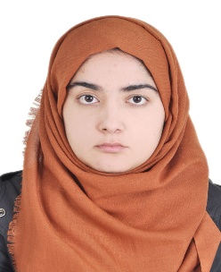

***Nabila Nazari***

Ms. Nabila holds a BA in Computer Science from Kabul University in 2012 and MA degree in Computer Science from Kabul University in Cooperation of Tallinn University in 2018. She has more than 6 years of professional experience with many international organizations and national educational institutions in Afghanistan. She has worked in the capacity of IT Officer and Coordinator, Software Development Specialist Trainer, EMIS Assistant and Database Developer with Kabul University Women Dormitory, USAID funded project, University of Jahan, Chemonics International, Ministry of Communications and Information Technology of Afghanistan and World Bank project. She received Best Research Topic, Inspiring women in Tech and Knowledge Growth awards during her academic and professional working years. She is fluent in Dari, Pashto and English.

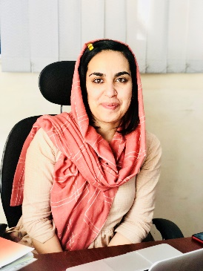***Elham Kohistani***

Ms. Elham Kohistani is young social and tech entrepreneur and women right activist. she received BA degree in Computer Sciences from Kabul University and a certificate in Entrepreneurship from Founder Institute and currently she pursues her master in International Relations with specialization in Peace and Conflict Resolutions at Kardan University. she has worked in different tech companies and tech-projects to increase women participation in technology meanwhile she has worked with different national and international organizations in the field of education, gender awareness and child protection. she is member of Afghanistan Startup Community to promote women startups. She is also founder of Course.af, Afghanistan’s first educational platform. In 2016 She was selected to represent Kapisa province in the Emerging Civil Society Leaders Programs with Counterpart International and USAID, and she is the board member of Afghanistan ECSLs Alumni network. In 2018 – she was honored Youth Ambassadors award from International youth Confederation based on her social activities for youth and women empowerment.

Meanwhile she is the community member of UNLEASH global lab to work for SDG 4 quality education and SDG 5 gender equality globally. She has traveled to India, Sri-Lanka and Singapore to find-out how Nation building, gender equality and conflict resolution took place of war, disagreements and social injustices. Currently she is working as a civil society activist to promote education and gender equality in Afghanistan, beside she working for Girls’ education challenge projects with DFID in most of Afghanistan provinces.She is fluent in Dari, Pashto, English and Urdu.

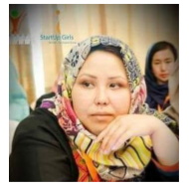***Masoma Rasuli***

Ms. Masoma is founder of Aliss Graphic. She earned BA in Information Technology from Kabul University in 2015. She has more than 5 years of working experience with different national and international organizations. She has worked as Researcher with Young Women for Change Organization, as Project Assistant in Pearl Horizon Consulting, as IT Officer & Admin Assistant for the Allied Afghan for Rural Development Organization (AARDO) and as Project Manager for Global Alliance for Improved Nutrition (GAIN) project. She also volunteered as Secretary for GIMUN in Herat in 2017 as well as HERAT 2017 as well as Startup Weekend Kabul in 2018. She is also one of startup graduates of Founder Institute Afghanistan. Ms. Masoma is an enthusiast professional in in Tech Entrepreneurship. She is fluent in Dari, English and Pashto.

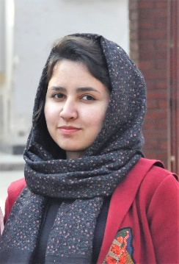***Elaaha Noorzad***

Ms. Elaaha has a BA in Computer Science from Kabul University in 2017. She started her career as a Programme Development Intern at AfghanAid, and then promoted to Programme Development and Reporting Assistant. In addition, she serves as volunteer to Internet Society (ISOC) Afghanistan through which she worked in the design and implementation of first of its kind Incredible Internet of Things (IoT) project in Afghanistan, a 4-day IoT awareness raising programme for high school students. This project won the third place for Afghanistan between 43 countries in Chapterthon 2018 which was organized by global team of Internet Society. Furthermore, Ms. Elaaha has served as a volunteer to organize DevFest 2018, one of the biggest tech events of Google which has been organizing by Google Developers Group Kabul. Ms. Elaaha believes that capacity building and providing professional support are the most important factors to engage more women in ICT study and career, and growing women’s professional network is making great contributions towards achieving this goal. She is fluent in Dari, Pashto and English.

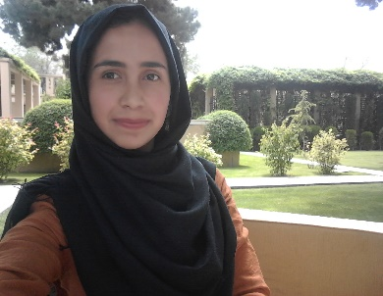***Najla Ahmadyar***

Ms. Najla Ahmadyar is a functional Software Engineer. Ms. Najla earned her Bachelor degree in Computer Science from Kabul Polytechnic University in 2017. She has more than 2 years of prosperous working experience in developing and management of different applications (web and desktop) with a number of considered private and government organizations. She has worked as web and software developer at Knight software development, and Software Developer Intern at National Procurement Authority, and currently working as freelancer at Strategic design Inc. She is also a great debater and participated in many different debate tournaments in Kabul. She is a strong believer in the power of positive thinking, dedication and honesty in the workplace. She is fluent in Dari, Pashto and English.

**NEED MORE INFORMATION, CONTACT US**

Name: Ms. Shabana Mansoory

Title: Organizing Team

Email: [shabanamansoory@gmail.com](mailto:shabanamansoory@gmail.com)

Web Address: [Under construction]

Contact Number: +93 (0) 728 101 847